.

NWFSC has FOUR Math Labs located at the Niceville, Fort Walton Beach, DeFuniak Springs, and Crestview Campuses. All four labs offer FREE TUTORING in all math subjects with NO APPOINTMENT NECESSARY! The Niceville and FWB labs have computers for student use, and offer videos and computer programs that pertain to math classes taught at NWFSC. There are tutorials on the computers in the Math Labs that supplement most of our books. Most of our textbooks have videos that can be found in all four Math Labs and in both libraries.

Many students go to the Math Lab in between classes to work their homework. Other students form study groups and meet in the math lab to study for an exam. Feel free to come as often as needed and stay as long as it takes! Again, it is free and you do not need an appointment!

ASSIGNMENT: Go to the NWFSC Math Lab website and fill in the tables below with this semester’s Math Lab Hours.

Niceville Math Lab

Niceville—Building L, room 131

Phone: 729-5377

Niceville Hours:
Monday
Tuesday
Wednesday
Thursday
Friday
Saturday

Fort Walton Beach Math Lab
Fort Walton Beach-Building 7, Room 702
Phone: 863-6520
Fort Walton Beach Hours:
Monday
Tuesday
Wednesday
Thursday
Friday
Saturday

Crestview Math Lab
Crestview-Room 141
Phone: 689-7911
Crestview Hours:
Monday
Tuesday
Wednesday
Thursday
Friday
Saturday

DeFuniak Springs Math Lab
Chautauqua Center-Room 202
Phone: 892-8100
DeFuniak Springs Hours:
Monday
Tuesday
Wednesday
Thursday
Friday
Saturday

Success in Mathematics
Tips on how to study mathematics,
how to approach problem-solving,
how to study for and take tests,
and when and how to get help.

Math Study Skills

Active Study vs. Passive Study
Be actively involved in managing the learning process, the mathematics and your study time:
- Take responsibility for studying, recognizing what you do and don't know, and knowing how to get your Instructor to help you with what you don't know.
- Attend class every day and take complete notes. Instructors formulate test questions based on material and examples covered in class as well as on those in the text.
- Be an active participant in the classroom. Get ahead in the book; try to work some of the problems before they are covered in class. Anticipate what the Instructor's next step will be.
- Ask questions in class! There are usually other students wanting to know the answers to the same questions you have.
- Go to office hours and ask questions. The Instructor will be pleased to see that you are interested, and you will be actively helping yourself.
- Good study habits throughout the semester make it easier to study for tests.

Studying Math is Different from Studying Other Subjects
- Math is learned by doing problems. Do the homework. The problems help you learn the formulas and techniques you do need to know, as well as improve your problem-solving prowess.
- A word of warning: Each class builds on the previous ones, all semester long. You must keep up with the Instructor: attend class, read the text and do homework every day. Falling a day behind puts you at a disadvantage. Falling a week behind puts you in deep trouble.
- A word of encouragement: Each class builds on the previous ones, all semester long. You're always reviewing previous material as you do new material. Many of the ideas hang together. Identifying and learning the key concepts means you don't have to memorize as much.

College Math is Different from High School Math
A College math class meets less often and covers material at about twice the pace that a High School course does. You are expected to absorb new material much more quickly. Tests are probably spaced farther apart and so cover more material than before. The Instructor may not even check your homework.
- Take responsibility for keeping up with the homework. Make sure you find out how to do it.
- You probably need to spend more time studying per week - you do more of the learning outside of class than in High School.
- Tests may seem harder just because they cover more material.

Study Time
You may know a rule of thumb about math (and other) classes: at least 2 hours of study time per class hour. But this may not be enough!
- Take as much time as you need to do all the homework and to get complete understanding of the material.
- Form a study group. Meet once or twice a week (also use the phone). Go over problems you've had trouble with. Either someone else in the group will help you, or you will discover you're all stuck on the same problems. Then it's time to get help from your Instructor.
- The more challenging the material, the more time you should spend on it.

Problem Solving

Tips on Problem Solving
- Apply Pólya's four-step process:
  - The first and most important step in solving a problem is to understand the problem, that is, identify exactly which quantity the problem is asking you to find or solve for (make sure you read the whole problem).
  - Next you need to devise a plan, that is, identify which skills and techniques you have learned can be applied to solve the problem at hand.
  - Carry out the plan.
  - Look back: Does the answer you found seem reasonable? Also review the problem and method of solution so that you will be able to more easily recognize and solve a similar problem.
- Some problem-solving strategies: use one or more variables, complete a table, consider a special case, look for a pattern, guess and test, draw a picture or diagram, make a list, solve a simpler related problem, use reasoning, work backward, solve an equation, look for a formula, use coordinates.

"Word" Problems are Really "Applied" Problems
The term "word problem" has only negative connotations. It's better to think of them as "applied problems". These problems should be the most interesting ones to solve. Sometimes the "applied" problems don't appear very realistic, but that's usually because the corresponding real applied problems are too hard or complicated to solve at your current level. But at least you get an idea of how the math you are learning can help solve actual real-world problems.

Solving an Applied Problem
- First convert the problem into mathematics. This step is (usually) the most challenging part of an applied problem. If possible, start by drawing a picture. Label it with all the quantities mentioned in the problem. If a quantity in the problem is not a fixed number, name it by a variable. Identify the goal of the problem. Then complete the conversion of the problem into math, i.e., find equations which describe relationships among the variables, and describe the goal of the problem mathematically.
- Solve the math problem you have generated, using whatever skills and techniques you need (refer to the four-step process above).
- As a final step, you should convert the answer of your math problem back into words, so that you have now solved the original applied problem.
For Further Reading:
George Pólya, How to Solve It,Princeton University Press, Princeton (1945)

Studying for a Math Test

Everyday Study is a Big Part of Test Preparation
Good study habits throughout the semester make it easier to study for tests.
- Do the homework when it is assigned. You cannot hope to cram 3 or 4 weeks worth of learning into a couple of days of study.
- On tests you have to solve problems; homework problems are the only way to get practice. As you do homework, make lists of formulas and techniques to use later when you study for tests.
- Ask your Instructor questions as they arise; don't wait until the day or two before a test. The questions you ask right before a test should be to clear up minor details.

Studying for a Test
· Start by going over each section, reviewing your notes and checking that you can still do the homework problems (actually work the problems again). Use the worked examples in the text and notes - cover up the solutions and work the problems yourself. Check your work against the solutions given.
· You're not ready yet! In the book each problem appears at the end of the section in which you learned how do to that problem; on a test the problems from different sections are all together.
- Step back and ask yourself what kind of problems you have learned how to solve, what techniques of solution you have learned, and how to tell which techniques go with which problems.
- Try to explain out loud, in your own words, how each solution strategy is used (e.g. how to solve a quadratic equation). If you get confused during a test, you can mentally return to your verbal "capsule instructions". Check your verbal explanations with a friend during a study session (it's more fun than talking to yourself!).
- Put yourself in a test-like situation: work problems from review sections at the end of chapters, and work old tests if you can find some. It's important to keep working problems the whole time you're studying.
· Also:
- Start studying early. Several days to a week before the test (longer for the final), begin to allot time in your schedule to reviewing for the test.
- Get lots of sleep the night before the test. Math tests are easier when you are mentally sharp.

Taking a Math Test

Test-Taking Strategy Matters
Just as it is important to think about how you spend your study time (in addition to actually doing the studying), it is important to think about what strategies you will use when you take a test (in addition to actually doing the problems on the test). Good test-taking strategy can make a big difference to your grade!

Taking a Test
- First look over the entire test. You'll get a sense of its length. Try to identify those problems you definitely know how to do right away, and those you expect to have to think about.
- Do the problems in the order that suits you! Start with the problems that you know for sure you can do. This builds confidence and means you don't miss any sure points just because you run out of time. Then try the problems you think you can figure out; then finally try the ones you are least sure about.
- Time is of the essence - work as quickly and continuously as you can while still writing legibly and showing all your work. If you get stuck on a problem, move on to another one - you can come back later.
- Work by the clock. On a 50 minute, 100 point test, you have about 5 minutes for a 10 point question. Starting with the easy questions will probably put you ahead of the clock. When you work on a harder problem, spend the allotted time (e.g., 5 minutes) on that question, and if you have not almost finished it, go on to another problem. Do not spend 20 minutes on a problem which will yield few or no points when there are other problems still to try.
- Show all your work: make it as easy as possible for the Instructor to see how much you do know. Try to write a well-reasoned solution. If your answer is incorrect, the Instructor will assign partial credit based on the work you show.
- Never waste time erasing! Just draw a line through the work you want ignored and move on. Not only does erasing waste precious time, but you may discover later that you erased something useful (and/or maybe worth partial credit if you cannot complete the problem). You are (usually) not required to fit your answer in the space provided - you can put your answer on another sheet to avoid needing to erase.
- In a multiple-step problem outline the steps before actually working the problem.
- Don't give up on a several-part problem just because you can't do the first part. Attempt the other part(s) - if the actual solution depends on the first part, at least explain how you would do it.
- Make sure you read the questions carefully, and do all parts of each problem.
- Verify your answers - does each answer make sense given the context of the problem?
- If you finish early, check every problem (that means rework everything from scratch). Do not feel rushed because students finish and leave before you. Often, the students that finish the exam first make careless mistakes.

Getting Assistance

When
Get help as soon as you need it. Don't wait until a test is near. The new material builds on the previous sections, so anything you don't understand now will make future material difficult to understand.

Use the Resources You Have Available
- Ask questions in class. You get help and stay actively involved in the class.
- Visit the Instructor's Office Hours. Instructors like to see students who want to help themselves.
- Ask friends, members of your study group, or anyone else who can help. The classmate who explains something to you learns just as much as you do, for he/she must think carefully about how to explain the particular concept or solution in a clear way. So don't be reluctant to ask a classmate.
- Go to the Math Lab (http://faculty.owc.edu/math/mathlab/index.htm) or the OWC Academic Success Center on campus for FREE TUTORING!
- Find a private tutor if you can't get enough help from other sources.
- All students need help at some point, so be sure to get the help you need.

Asking Questions
Don't be afraid to ask questions. Any question is better than no question at all (at least your Instructor/tutor will know you are confused). But a good question will allow your helper to quickly identify exactly what you don't understand.
- Not too helpful comment: "I don't understand this section." The best you can expect in reply to such a remark is a brief review of the section, and this will likely overlook the particular thing(s) which you don't understand.
- Good comment: "I don't understand why 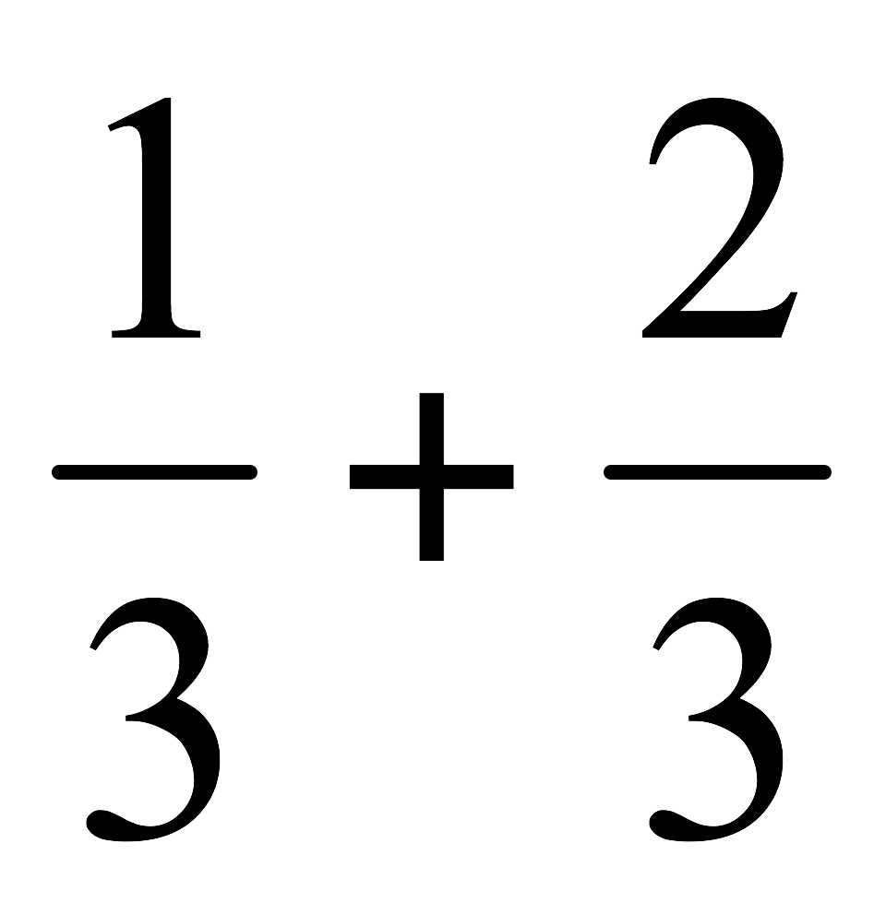 doesn't equal ." This is a very specific remark that will get a very specific response and hopefully clear up your difficulty.
- Good question: "How can you tell the difference between a binomial and a trinomial?"
- Okay question: "How do you do #17?"
- Better question: "Can you show me how to set up #17?" (the Instructor can let you try to finish the problem on your own), or "This is how I tried to do #17. What went wrong?" The focus of attention is on your thought process.
- Right after you get help with a problem, work another similar problem by yourself.

You Control the Help You Get
Helpers should be coaches, not crutches. They should encourage you, give you hints as you need them, and sometimes show you how to do problems. But they should not, nor be expected to, actually do the work you need to do. They are there to help you figure out how to learn math for yourself.
- When you go to office hours, your study group or a tutor, have a specific list of questions prepared in advance. You should run the session as much as possible.
- Do not allow yourself to become dependent on a tutor. The tutor cannot take the exams for you. You must take care to be the one in control of tutoring sessions.
- You must recognize that sometimes you do need some coaching to help you through, and it is up to you to seek out that coaching.
Source for Success in Mathematics: Department of Mathematics and Computer Science’s Website:
http://euler.slu.edu/Dept/SuccessinMath.html#studytest
SAINT LOUIS UNIVERSITY June 1993
*only changes are highlighted

